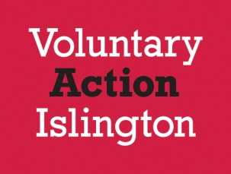

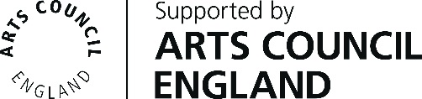

Booking Form

Meet the Funders

The Arts Council England & Islington Council

Tuesday 23rd April 2019

2.00pm – 4.15pm

Name/s of attendees
Organisation
Address including post code
Phone Number
Email

Return to: advice@vai.org.uk or Voluntary Action Islington, 200a Pentonville Road, London, N1 9JP.

