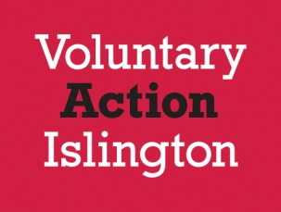

Booking Form

Meet the Funders

Wednesday 15th March 2017

2pm - 4pm

Name
Organisation & address including post code
Phone Number
Email

Return to: yvette.ellis@vai.org.uk or Voluntary Action Islington, 200a Pentonville Road,London, N1 9JP.

