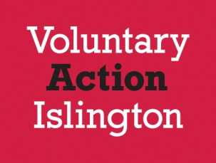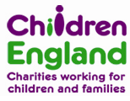

A free commissioning and tendering training session for the Children, Young People and Families volun­tary and community sector organisations in Islington

**Commissioning & Tendering Master Class**

**Friday 25th July 10am - 4.30pm**

**Voluntary Action Islington, 200a Pentonville Road, London N1 9JP**

**Aims, objectives and learning outcomes of the course:**

• To raise awareness of the national and local context of commissioning and procurement

• To increase confidence, knowledge & ability in tendering & developing effective business plans for the future

• To support the local sector to understand commissioning and procurement at a strategic level and influence the design and development of the strategic commissioning processes.

**This training is aimed at:**

• VCS organisations seeking to bid competitively for contracts to deliver services to children, young people and families

• VCS representatives on statutory sector strategic commissioning boards and groups

• VCS organisations that have had some experience, and wish to improve their ability, knowl­edge and confidence in tendering competitively.

**To book your place**, please email

[marta.crespo@vai.org.uk](mailto:marta.crespo@vai.org.uk)

For booking enquiries, telephone Voluntary Action Islington on: 020 7832 5800

This programme is being delivered by Children England in partnership with Voluntary Action Islington and the London Borough of Islington.

Voluntary Action Islington: Registered Charity No: 291890  Company Limited by Guarantee No: 1913555