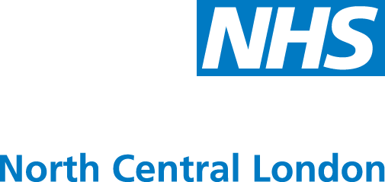
Islington Health

A newsletter for Patient and Public Representatives in Islington
Issue 1: Autumn 2011
Welcome
It is with great pleasure that I introduce myself. My name is Dr Katie Coleman and I am a GP in south Islington and joint Vice-Chair of the Islington Clinical Commissioning group.

As many of you will know, the government, as part of the new white paper for health, “Equity and excellence: Liberating the NHS” has agreed that patient services should be commissioned by Clinical Commissioning Groups (CCG) made up of the GP practices within a defined area. The CCGs will be supported by a board made up of local GPs, hospital clinicians, nurses and other local stakeholders. Each board member will have different areas on which they lead, and one of my lead areas is patient participation and equality and diversity.

The Islington CCG aims to put patients at the heart of all commissioning decisions, ensuring that services are responsive to their needs and promoting improved health and quality of life by providing patients with opportunities to take an active role in their own care. I look forward to working with many of you in the future so that together we can achieve our objectives.

We hope you enjoy this newsletter and welcome any feedback. If you are interested in getting involved, please contact Sam Milford at Samantha.Milford@nclondon.nhs.uk. You can also make contact through other routes which can be found by visiting www.islington.nhs.uk/Listening-to-you/listening-to-you.htm.

Dr Katie Coleman, Joint Vice-Chair, Islington CCG and GP at The City Road Medical Centre
.

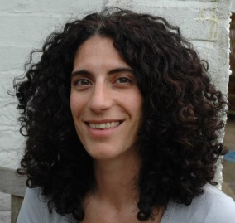
Your newsletter needs a name!
As you will notice, the look of the Islington Health newsletter has changed and we want to know how you feel about the name. Do you think it needs a change or do you like the way it is?
We would love to hear any suggestions you have – the name should reflect the fact that the newsletter is for you, the patients and the public of Islington, and that it is providing health information.

So, get creative and send your suggestions to the Communications and Engagement Team at engagement@nclondon.nhs.uk by 30 November 2011.

Your local GP practice needs you!
Each GP Practice in Islington is setting up its own ‘Patient Reference Group’, with the intention of involving patients in the particular services that their surgery offers and the way they are delivered. If you are interested in having your say in your GP practice’s services, then
contact your practice manager or receptionist to enquire about how you can
become a part of a Patient Reference Group. This is your opportunity to
make a difference!

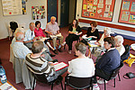

Islington NHS Health Checks underway
Circulatory diseases are still the leading cause of death in Islington for people under 75. The NHS Health Check aims to help people lower their risk of four common, but often preventable diseases: heart disease, stroke, diabetes, and kidney disease.

If you are an Islington resident aged 35-74 with no previous history of heart disease, you will be invited by your GP to have a health check during the next two years. You can also arrange to have a health check yourself at one of the participating pharmacies offering free health checks. The check takes 20-30 minutes and involves asking some simple questions about people's lifestyle, taking measurements such as weight, height and blood pressure and performing a cholesterol test.

After the check, the results can be discussed with a health professional, people can get advice on how to improve their lifestyle and, if necessary, get treatment to keep them in good health.

For more information, please see www.islington.nhs.uk/nhs-health-check.htm.

1: Summer 2011
Phlebotomy in South and Central localities
We know that travelling to hospital for blood tests is inconvenient for many people. Therefore, GP practices in South and Central Islington have chosen to reinvest saved money to provide a blood testing service from a few local surgeries. Contact your GP to find out the times and locations of these clinics.

If you normally attend a GP practice in Central or South Islington, you will now
be given the choice to attend one of the community clinics in your locality or the
hospital, to get your blood test done. Your GP will give you the appropriate form blood forms and maps with local bus routes to help you plan your journey. You do not
need to make an appointment at the clinic; just walk in during the opening
hours and take a ticket - the last ticket will be issued 30 minutes before the end of the session. Results can be obtained from your own GP surgery. Ask your GP for more information.

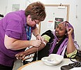

Volunteers needed to join Individual Funding Requests panel
Individual Funding Requests (IFRs) are requests by patients or GPs for treatments which are not normally funded. Procedures and drugs are constantly being developed while at the same time the funds the NHS has available are limited and must be used as effectively and efficiently as possible. Hence some treatments are only funded in certain circumstances, to be reviewed on a case by case basis. These cases, involving patients with unusual or unique clinical factors, are considered by an IFR Panel and NHS North Central London is looking for patient representatives to sit on this panel.
The IFR Panel will meet every Thursday afternoon at NHS NCL headquarters. Patient Representatives will not be expected to attend every meeting and each Representative will be required to attend one meeting every 5-6 weeks.
Anyone who is interested should contact Tammy Nicholls on 020 7685 6293 or tammy.nicholls@nclondon.nhs.uk for a Role Summary and Terms of Reference.

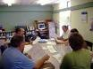

Service Improvement Group – We need volunteers!
To ensure services for patients in Islington are of high quality and are cost effective, we are in the process of reviewing services through our Service Improvement Group, and its more specific subgroups which focus on certain areas of health. By ensuring patients are represented on these groups, Islington Clinical Commissioning Group will ensure that the recommendation ‘No decision about me, without me’ is taken to the heart of the organisation. We are keen to find interested patients who have experience of any of the following services:

The overall Service Improvement Group (which will discuss overall services etc.)Elective care Learning disabilities (looking for carers)Care closer to homePalliative careMental HealthChildren’s health (looking for parents)Primary care and preventionUnscheduled careOlder peopleMedicines managementPatient participation, Equality and Diversity Working group
We aim to have a minimum of two patients on each group. Patients will be provided with a clear understanding of their role, support and personal development opportunities.
If you are interested, please contact Sam Milford on 020 7527 1343 or email samantha.milford@nclondon.nhs.uk

Medicines Management at your GP practice
The Medicines Management Team in Islington is currently providing intensive support to local GP practices in the form of “hands on help”. Local Prescribing Advisors are visiting practices to help them review medicines. The aim is to ensure medicines are in line with the most recent evidence and guidance as well as ensuring that they are the most cost-effective for you as the patient, and the NHS. It will prevent waste and increase sustainability of the current service to residents. This help will also allow reviews that support safe prescribing and improve patient outcomes and satisfaction.

What does this mean for patients?
The Team will review medicines at GP practices and then make recommendations. Where there is an equally effective medicine available at a significantly lower cost, your GP may change one or more of your medicines accordingly. This may mean taking fewer tablets or capsules of your existing medicines, or using generic medicines instead of branded medicines. Branded medicines are more expensive and are not a good use of limited resources. The medicines will all be fully licensed and their clinical effectiveness based on the latest evidence from national bodies such as NICE.

All recommendations will be reviewed by your GP and any decision they make will be theirs and in the best interest of their patients. You may therefore be contacted by your practice if a change has been made or your GP is considering a change to your medicine.

Age UK Islington Older Peoples Reference Group is looking for volunteers
Islington Older Peoples Reference Group is made up of local older people wanting to help improve and develop services and facilities for older people in Islington. To get involved, please contact Suj Ahmed on 020 7281 6018 (extension 24) or email suj.ahmed@ageukislington.org.uk.

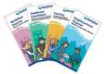
Patient Information Reading Group
NHS North Central London is looking for volunteers from Islington to join our Patient Information Reading Group. This group ensures that leaflets, letters and surveys can be easily read and understood. Even if English is not your first language, you can still help as some of the publications looked at are translated into other languages. There is no great time commitment and you can choose how much time you wish to devote to the group.

To join the Patient Information Reading Group or for more information contact Fatima Khanum, Communications Assistant on 020 7685 6285 or email fatima.khanum@nclondon.nhs.uk

Think LINk
Want to influence services in your local area? Islington LINk collects the views and experiences of local people using health and care services in Islington. The LINk uses those views to influence how services are planned and delivered. Local people told LINk that hospital discharge was confusing and LINk worked with the Whittington to improve this for patients. Young carers told LINk that it was hard for them to access services designed for them. The information LINk collected has helped shape the council's new Young Carer's Strategy. To give LINk your views
on local health and social care services or to join us as a volunteer, visit
LINk@vai.org.uk or call 020 7832 5814.

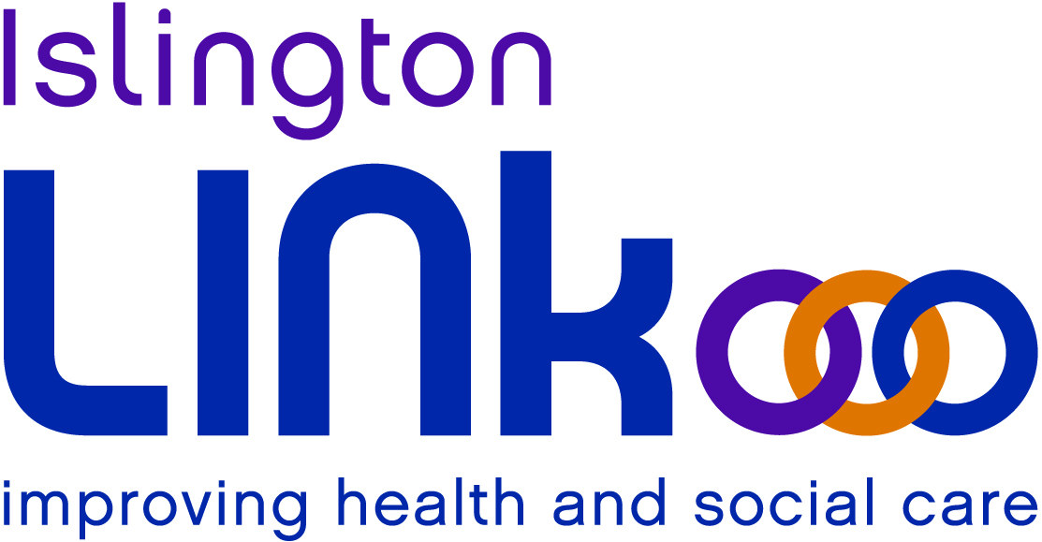

Tell us what you think by joining Islington's new Online Panel
Islington Council is setting up a new online panel to find out what Islington residents think about their area, local services and other issues. Anyone who lives in Islington and has an e-mail address can join. To let us know if you are interested in joining the panel, or to find out more, visit:
www.islington.gov.uk/Council/CouncilNews/consultation/consult_citizen.asp

Islington wants to hear your views!
Are you an Islington patient who is interested in healthcare across Islington? You can become a part of locality and pan-Islington patient group quarterly meetings. Islington has wider Patient Participation Groups which discuss health services across Islington, including community and hospital services, and inform you about how Islington is progressing as a borough in healthcare matters.

Please contact Sam Milford on 020 7527 1343, or samantha.milford@nclondon.nhs.uk for more information or to take part! We value your views and would love to hear from you.

Contact Us
If you have any comments or queries, please contact the Communications and Engagement Team at NHS North Central London as follows:
Robyn Sandler, Senior Communications and Engagement Officer: 020 7685 6279
Stephen Craker, Head of Engagement and Corporate Communications: 020 7685 6276
Fatima Khanum, Communications & Engagement Assistant: 020 7685 6285

Alternatively, please email engagement@nclondon.nhs.uk

